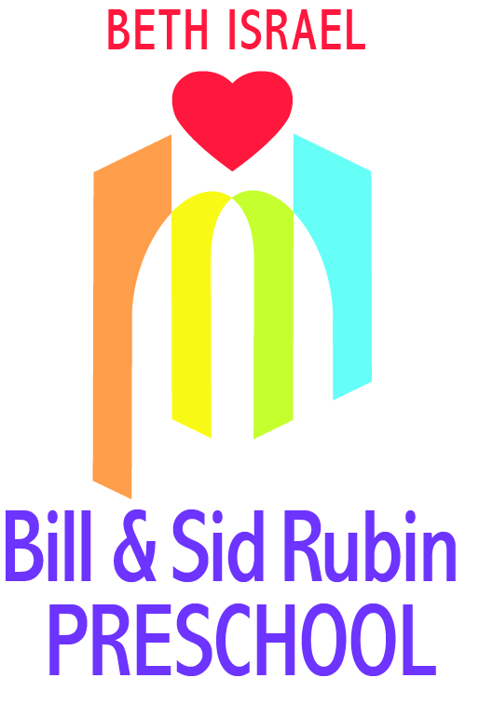
BIBS: Beth Israel Babies
Spring 2019

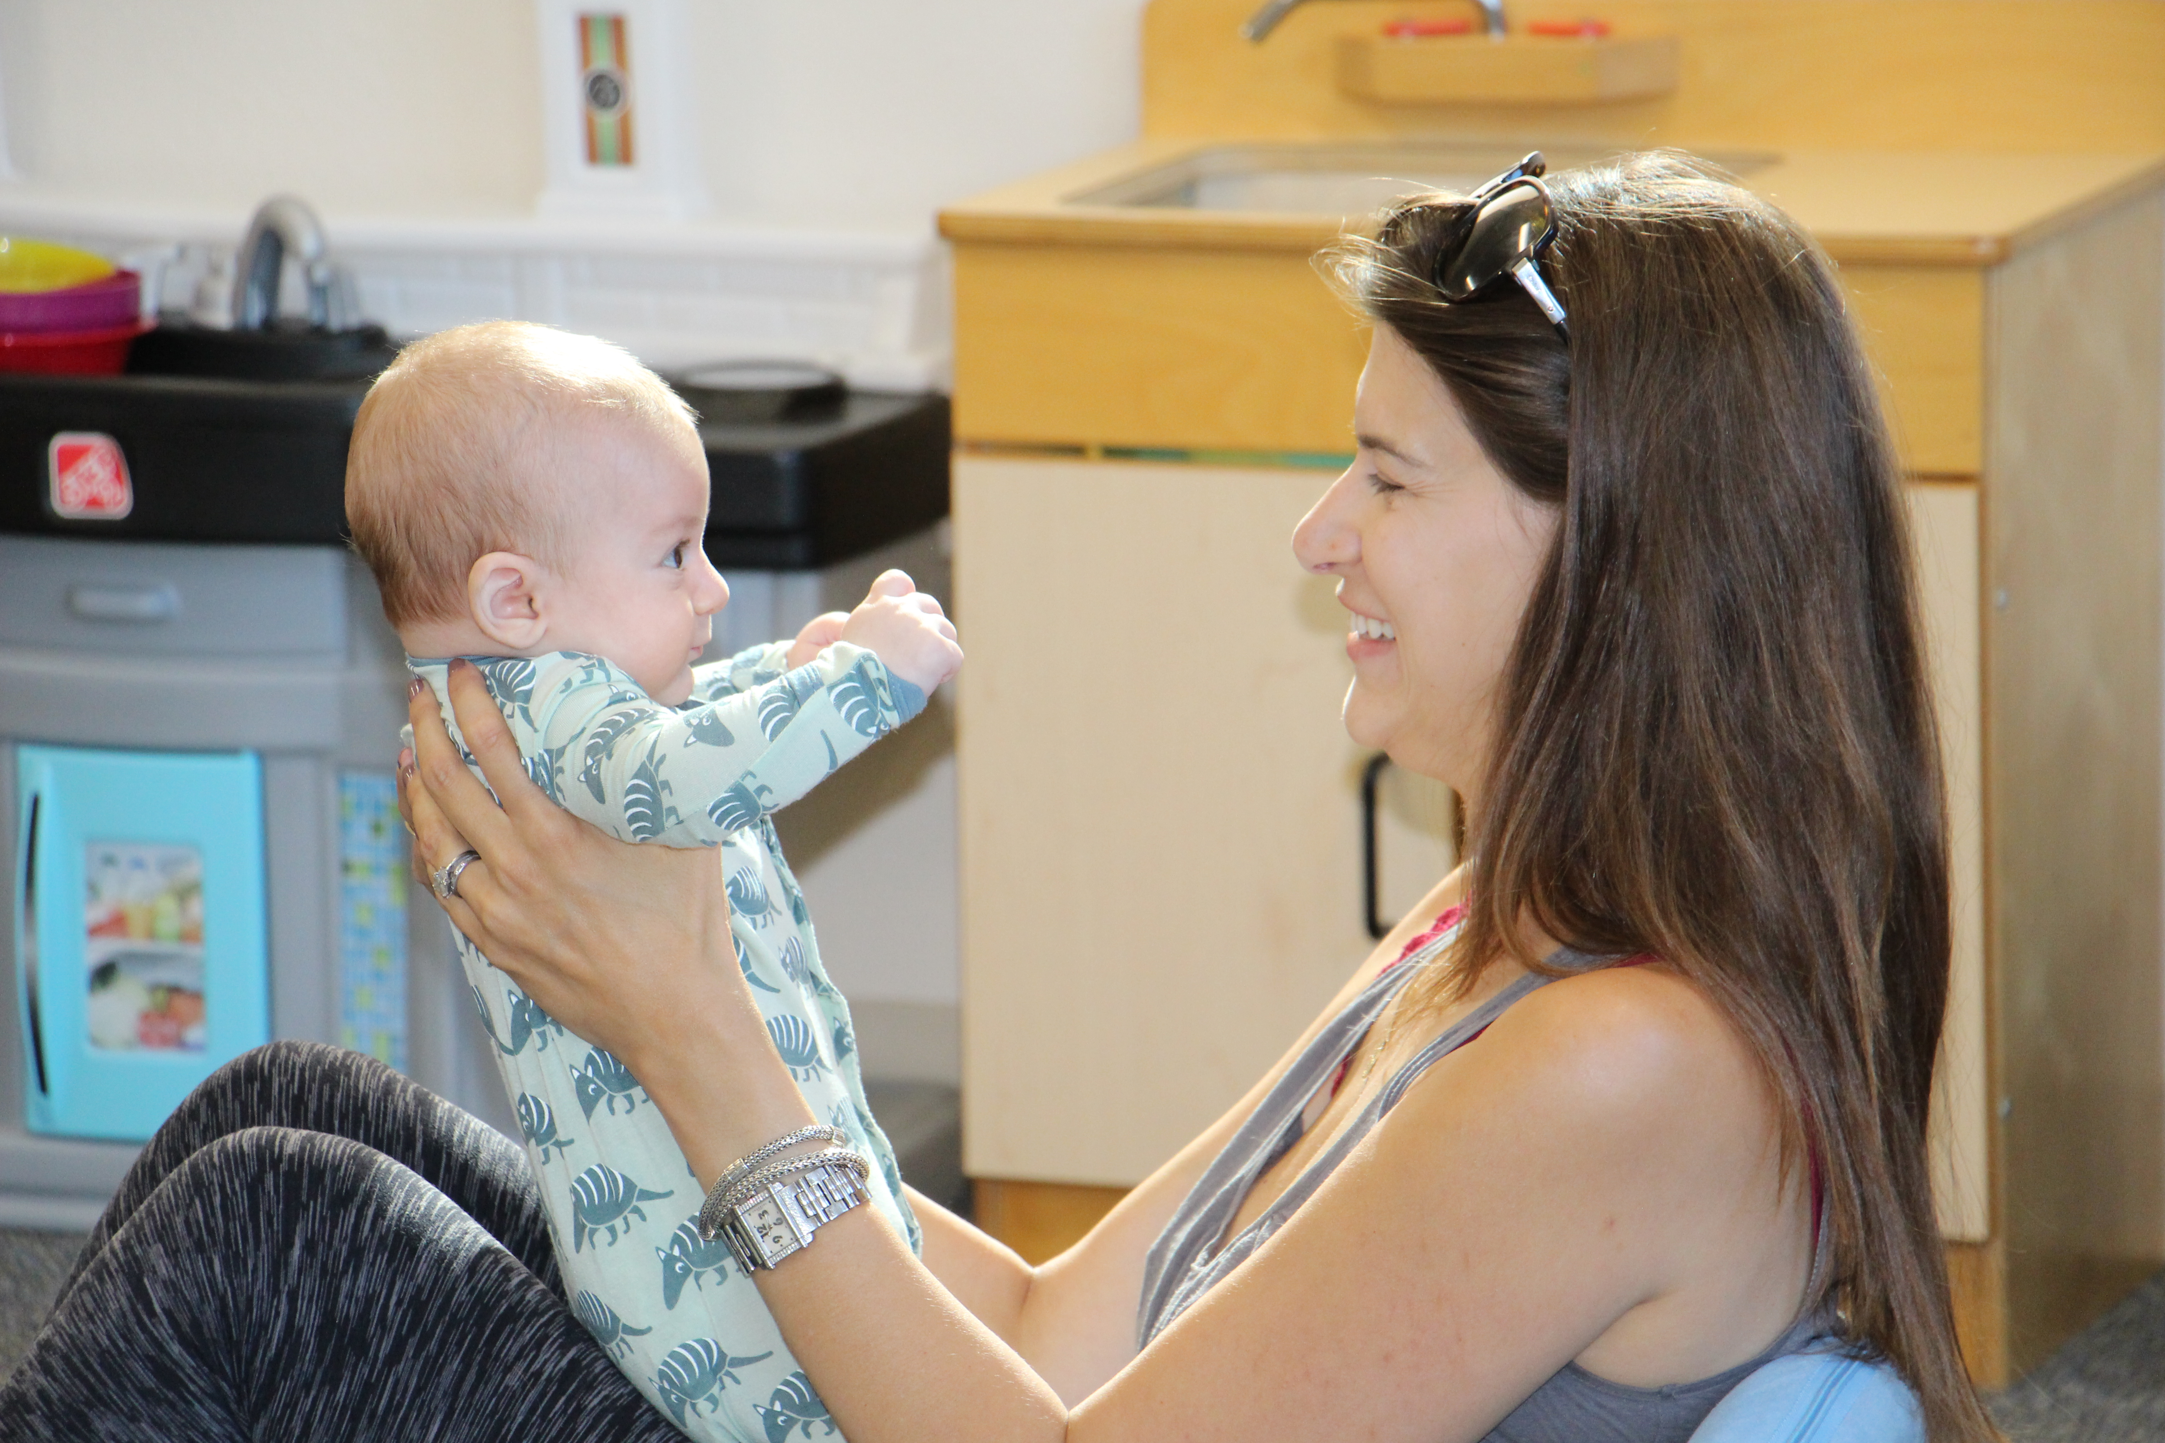


Welcome to the Wonderful World of BIBS
Beth Israel Babies is a lively, multi-faceted program for young children ages 3 months through 2 years of age. Our younger class begins at lap baby age through 12 months of age. Our older class begins at 12 months through 2 years of age. These classes combine developmentally appropriate AND stimulating activities for children, while providing a supportive environment for parents.

Our goal is to provide a nurturing, safe and stimulating environment for the children and supportive, informative classes for the parents. We hope to create a lasting group of parent friendships, with children of similar ages.

Our Infant-Toddler Specialist, Kimberly Raoufpur, will facilitate children and their parents in activities which encourages the development of the whole child; focusing on socialization as well as physical and cognitive growth. Children will have the opportunity to explore and learn in our age-appropriate classroom. This entertaining program includes: stories, puppets, instruments/movement/music, parachute time, art, sensory and gross motor play. Parents will have one-on-one time with their child in a classroom setting, while also revisiting developmental milestones, discussion of the dynamics of your growing families and making new friends.
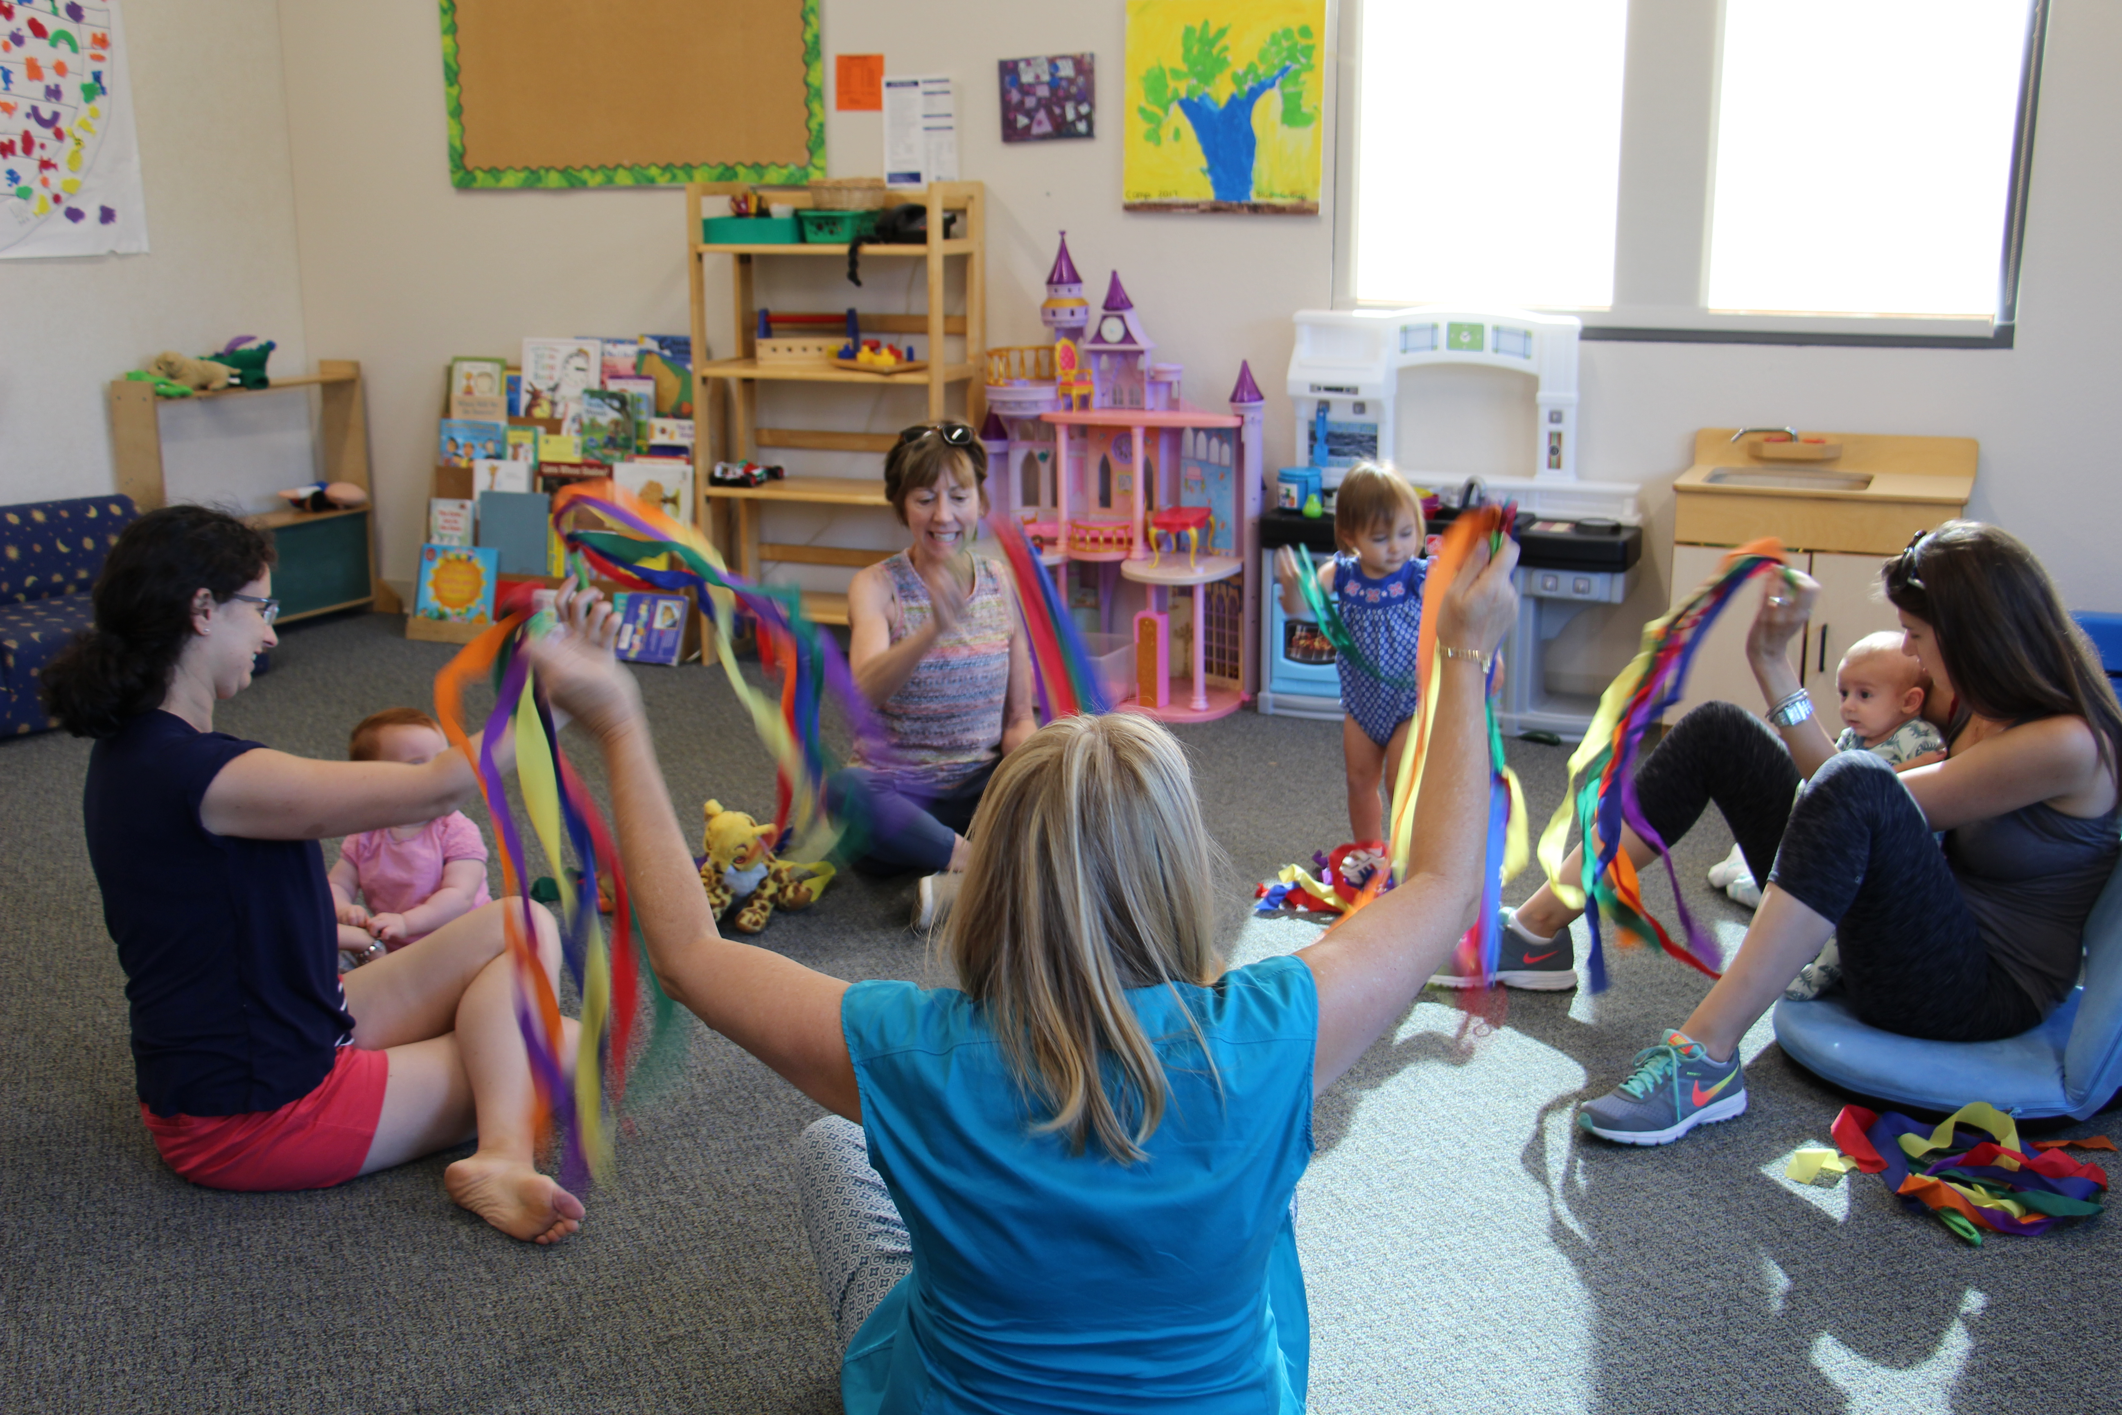
BIBS class meets weekly: Wednesday Mornings
- 9:15-10:30 am BIBS A (12- 24 months)
- 11:15-12:30pm BIBS B (Lap Babies-12 months)
- *There is a minimum enrollment of 4 children*

Dates: Feb. 6, 13, 20, 27; Mar. 6, 13, 20, 27; April 3, 10, 17; May 1, 8, 15, 22

Cost:
$25.00 Registration fee for Members and Non-Members
15 Free classes for Members BIBS A or B (Lap baby-24 months) / $150 for Non-Members

BIBS: Beth Israel Babies

Bill & Sid Rubin Preschool, BIBS Registration Form
Feb. 6 – May 22, 2019

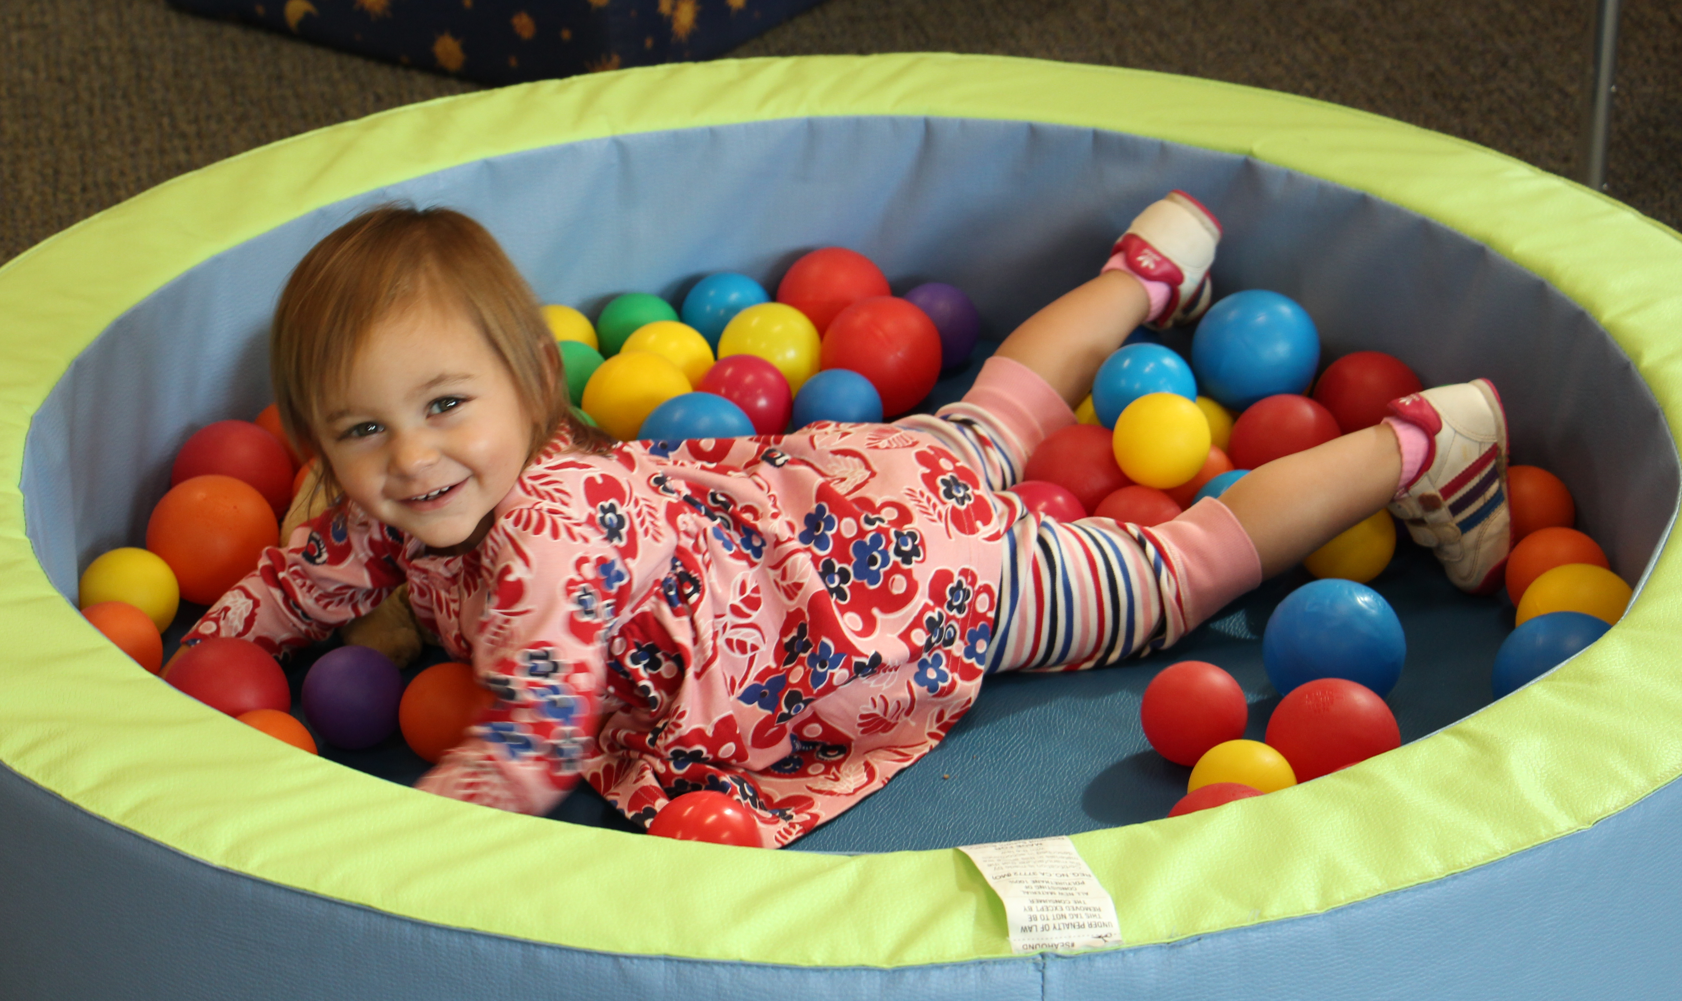

Child’s Name_____________________________________________________

□ Male □ Female Date of Birth _________________

Complete Address________________________________________________________________________________

Parent 1: _____________________________________________________ Telephone: ____________________

Alternate Phone: ______________________ Email: _______________________________________

Parent 2: _____________________________________________________ Telephone: ____________________

Alternate Phone: ______________________ Email: _______________________________________

Beth Israel Member? □ Yes □ No Would you like to be on our early childhood mailing list? □ Yes □ No
Cost: $25.00 application fee
15 Free classes for Members BIBS A or B / $150 for Non-Members

□ Enclosed is my check in the amount of $____________ payable to Congregation Beth Israel

□ Please charge my _____VISA _____Mastercard _____AMEX _____Discover in the amount of $

Account Number________________________________________ Exp Date_______________ Zip Code

______________________________________________ _______________________________________________

Printed name of card holder Signature of card holder



